PharmaSUG 2024 - Paper XX- ###

Complex Custom Clinical Graphs

Step by Step with SAS® ODS Statistical Graphics

Richann Jean Watson, DataRich Consulting;

Joshua Horstman, Nested Loop Consulting

# Abstract

The ODS Statistical Graphics package is a powerful tool for creating the complex, highly customized graphs often produced when reporting clinical trial results. These tools include the ODS Statistical Graphics procedures, such as the SGPLOT procedure, as well as the Graph Template Language (GTL). The SG procedures give the programmer a convenient procedural interface to much of the functionality of ODS Statistical Graphics, while GTL provides unparalleled flexibility to customize nearly any graph that one can imagine. In this hands-on workshop, we step through a series of increasingly sophisticated examples demonstrating how to use these tools to build clinical graphics by starting with a basic plot and adding additional elements until the desired result is achieved.

# Starting with a Basic Graph

Building a simple bar chart with the titles and footnotes in the system header/footer section.

# Adding Titles and Footnotes in the Graph area

By default, titles and footnotes are placed within the system header/footer section of the document. However, the titles and footnotes can be added to the graph area.

# Embedding a Table Within a Graph

Adding statistics to a table can help to convey the message. Data can be added as labels to the point itself (as seen in the basic graph) or it can be a table of information that needs to be included.

Two different techniques for embedding a table of information into the graph are illustrated.

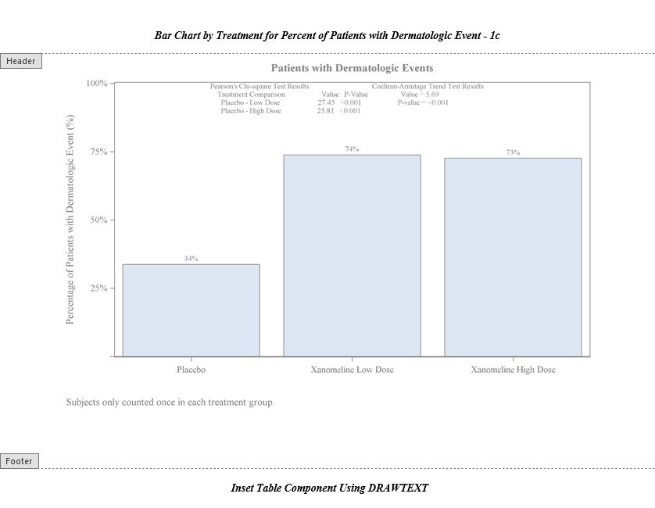

# Adding a Table Outside the Graph

Sometimes there may not be adequate space within the table but the table of information still needs to be included with the graph. This table of information can be placed on the outside of the graph.

